

|  |
| --- |



|  |
| --- |



**Team22_Milestone 01**

**Design and Simulation of a 3-4 DoF Agricultural Robotic Arm for Automated Harvesting and Sorting**

Abdullah Ksaybati, Mohamed Abdelrazek,Ahmad Imadeddin , Youssef Saifeldin , Farida Farouk, Youssef Khaled

**Abstract-This milestone presents the initial design and proposal for an agricultural robotic arm intended for automated harvesting and sorting of fruits and vegetables in controlled environments such as greenhouses. A literature review of recent studies (2020–2022) highlights advancements in robotic manipulators for delicate handling, precision harvesting, pruning, and crop monitoring. Based on these insights, a 3-4 Degrees of Freedom (DoF) manipulator was selected, featuring a soft gripper and servo motor actuation. A draft project flow was developed, detailing the steps from CAD modeling and component selection to software installation, simulation, and control algorithm development. The proposed system leverages ROS Noetic, Simscape Multibody, and Webots/Gazebo simulators for testing and visualization. This milestone establishes the groundwork for developing a fully functional agricultural robotic arm capable of improving efficiency, accuracy, and crop safety in farming operations.**

**Keywords:**

* **Agricultural Robotics**
* **Robotic Manipulator**
* **3-4 Degrees of Freedom (DoF)**
* **Soft Gripper**
* **Servo Motors**
* **ROS Noetic**
* **Simscape Multibody**
* **Greenhouse Automation**
* **Crop Harvesting**
* **Robot Simulation**

1. **Literature Review**

Agricultural robotics is an emerging field aiming to automate labor-intensive and precision tasks in farming, such as planting, harvesting, pruning, and crop monitoring. Robotic arms are increasingly adopted in agriculture for their accuracy, adaptability, and efficiency, particularly in greenhouse environments and high-value crops. Below is a review of recent studies highlighting advancements in this field:

**1. Robotic Harvesting of Fruits Using Machine Vision and Manipulators (Li et al., 2020)**

* **Journal:** Computers and Electronics in Agriculture
* **Summary:** This paper presents a robotic arm integrated with machine vision to identify and harvest fruits such as apples and strawberries. The system uses a 6-DoF robotic manipulator equipped with a soft gripper to avoid damaging fruits. Vision-based segmentation and deep learning algorithms guide the manipulator’s movement.
* **Relevance:** The study demonstrates the effectiveness of robotic arms in delicate harvesting tasks, highlighting the importance of vision-guided control and soft gripping mechanisms.

**2. Autonomous Greenhouse Robotic Arm for Plant Pruning (Zhang et al., 2021)**

* **Journal:** Robotics and Autonomous Systems
* **Summary:** Researchers designed a robotic arm for pruning tomato plants in greenhouse environments. The system integrates real-time environmental sensing, motion planning, and path optimization to reduce plant damage while increasing pruning efficiency.
* **Relevance:** This paper emphasizes precision tasks in confined agricultural spaces, illustrating how robotic manipulators can perform repetitive tasks efficiently.

**3. Crop Monitoring Using Robotic Manipulators and Sensors (Patel & Singh, 2022)**

* **Journal:** Sensors (MDPI)
* **Summary:** A robotic arm equipped with multispectral cameras and environmental sensors performs crop monitoring, identifying plant health and detecting diseases early. Data collected is processed using AI algorithms to guide targeted interventions.
* **Relevance:** This research highlights the use of robotic arms for data collection and monitoring, essential for precision agriculture and reducing chemical usage.

**4. Soft Robotic Manipulator for Harvesting Delicate Crops (Chen et al., 2020)**

* **Journal:** IEEE Robotics and Automation Letters
* **Summary:** The paper proposes a soft robotic arm with flexible actuators for harvesting delicate crops such as tomatoes and berries. The soft gripper adapts to irregular shapes, minimizing bruising. Kinematic analysis ensures smooth motion planning.
* **Relevance:** Soft robotics in agriculture is key to handling delicate products, which is a crucial consideration for designing an agricultural manipulator.

**5. Robotic Arm for Autonomous Weeding and Crop Maintenance (Huang et al., 2021)**

* **Journal:** Precision Agriculture
* **Summary:** This study introduces a robotic arm designed for autonomous weeding in row crops. It uses a combination of computer vision and path planning algorithms to distinguish weeds from crops and mechanically remove them without chemical use.
* **Relevance:** Demonstrates multi-task capability of agricultural robotic arms beyond harvesting, including precision weeding and crop maintenance.

1. **INTRODUCTION**

Automation in agriculture is increasingly used to improve efficiency, precision, and reduce labor in tasks like harvesting and sorting. Robotic arms can perform delicate operations with minimal damage, making them ideal for controlled environments such as greenhouses.

In this project, we focus on a **3-4 Degrees of Freedom (DoF) agricultural robotic arm** equipped with a soft gripper and servo motors for precise handling of fruits and vegetables.

The objectives of Milestone 1 are to review recent agricultural robotic applications, propose a project flow, select components available in the Egyptian market, and set up the simulation environment using ROS, Simscape Multibody, and Gazebo/Webots.

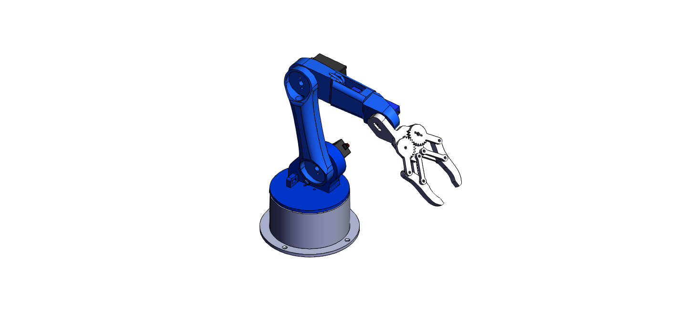

Fig. 1:Robotic Arm 3D Model

1. **Hardware Components**

1)Component: Servo Motors Description: For controlling the joints and gripper movement. Quantity: Source: Local electronics store Cost (EGP):~ 125-250

2)Component: Gripper/Claw Description: Mechanical gripper to hold objects securely. Quantity: 1 Source: Local robotics supplier Cost (EGP): 500

3)Component: Microcontroller (e.g., Raspberry pi) Description: Controls the servo motors and manages input from sensors. Quantity: 1 Source: Online electronics retailer Cost (EGP): 5000

4)Component: Power Supply Description: Provides necessary voltage and current to the system. Quantity: 1 Source: Local electronics store Cost (EGP): 250

5)Component: Jumper Wires Description: Used for connecting components on the breadboard or PCB. Quantity: 1 pack Source: Local electronics store Cost (EGP): 50

6)Component: Breadboard Description: For prototyping and connecting electronic components. Quantity: 1 Source: Local electronics store Cost (EGP): 100

7)Component: Force Sensor Description: To detect the gripping force and ensure proper object handling. Quantity: 1 Source: Local electronics store Cost (EGP): 250

8)Component: Chassis/Frame Description: Structure to hold all components together. Quantity: 1 Source: Local robotics supplier Cost (EGP): ~2000

9)Component: Cables and Connectors Description: For electrical connections between components. Quantity: 1 pack Source: Local electronics store Cost (EGP): 70

1. **ROBOT’S FRAME ASSIGNMENT**

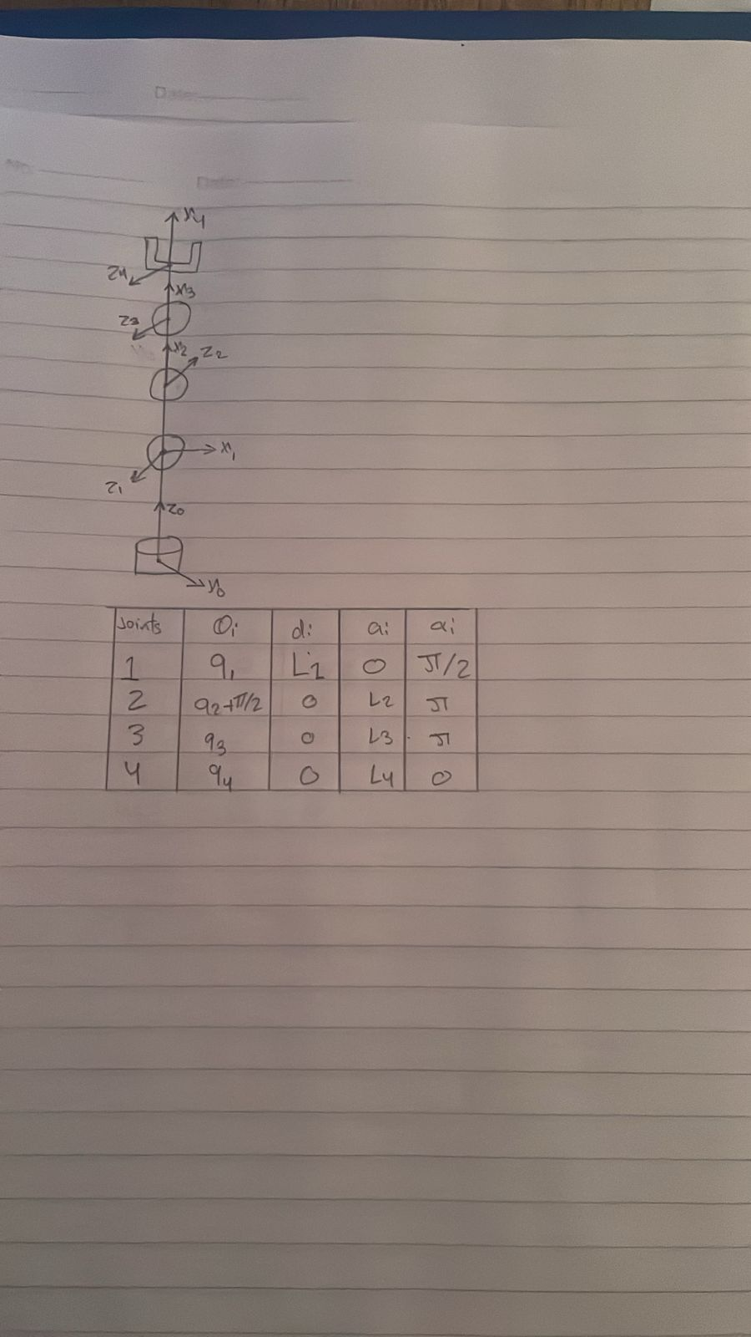

1. **DH CONVENTION**



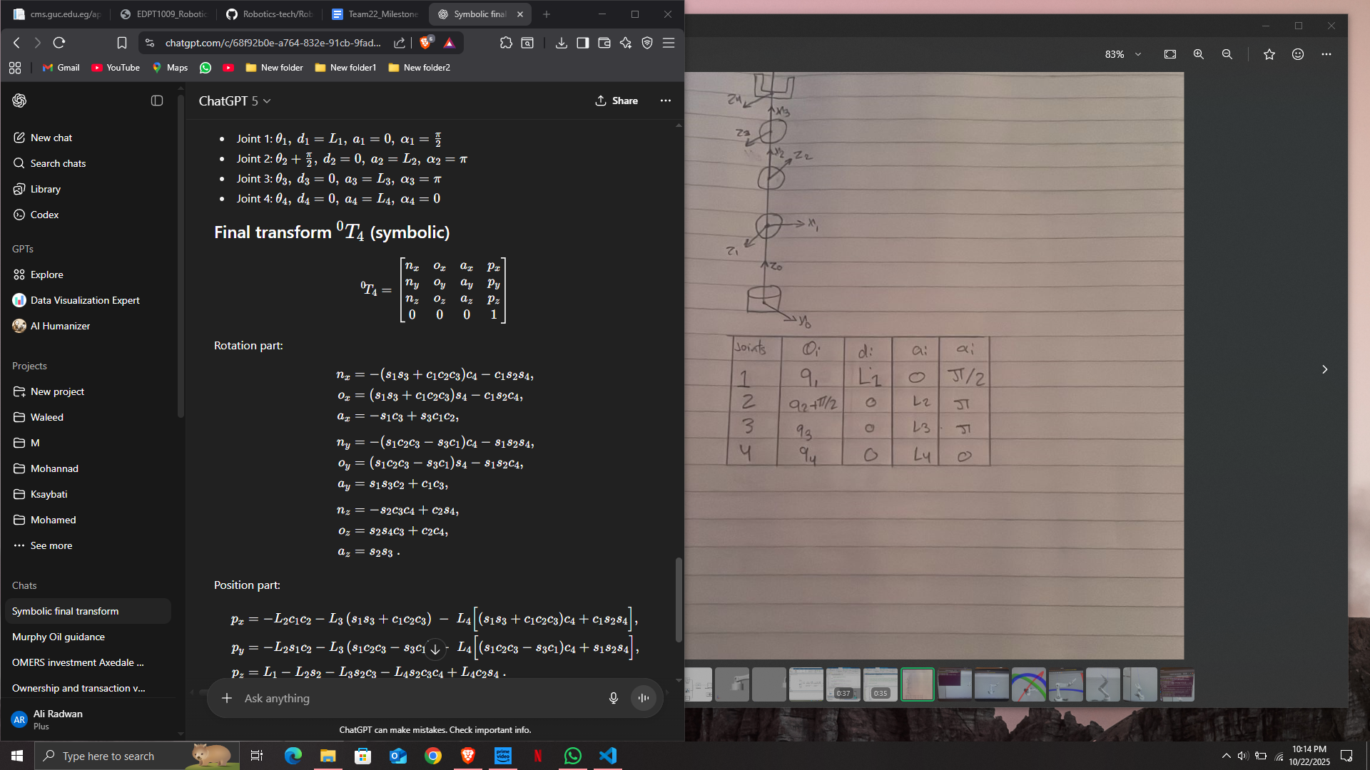

1. **SIMULATION RESULTS**

1)Gazebo

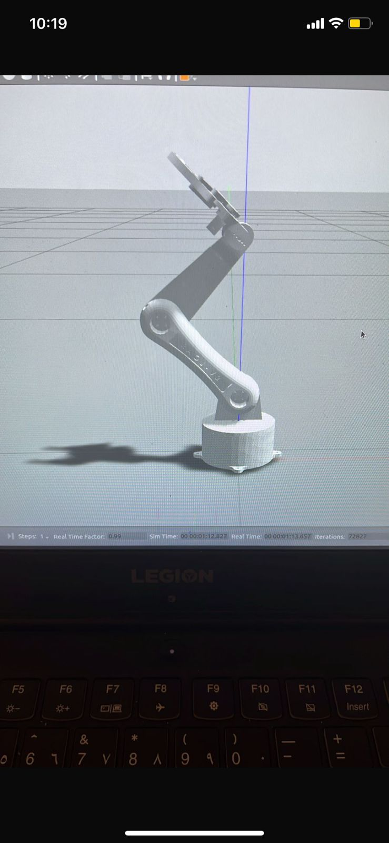

2)Simscape

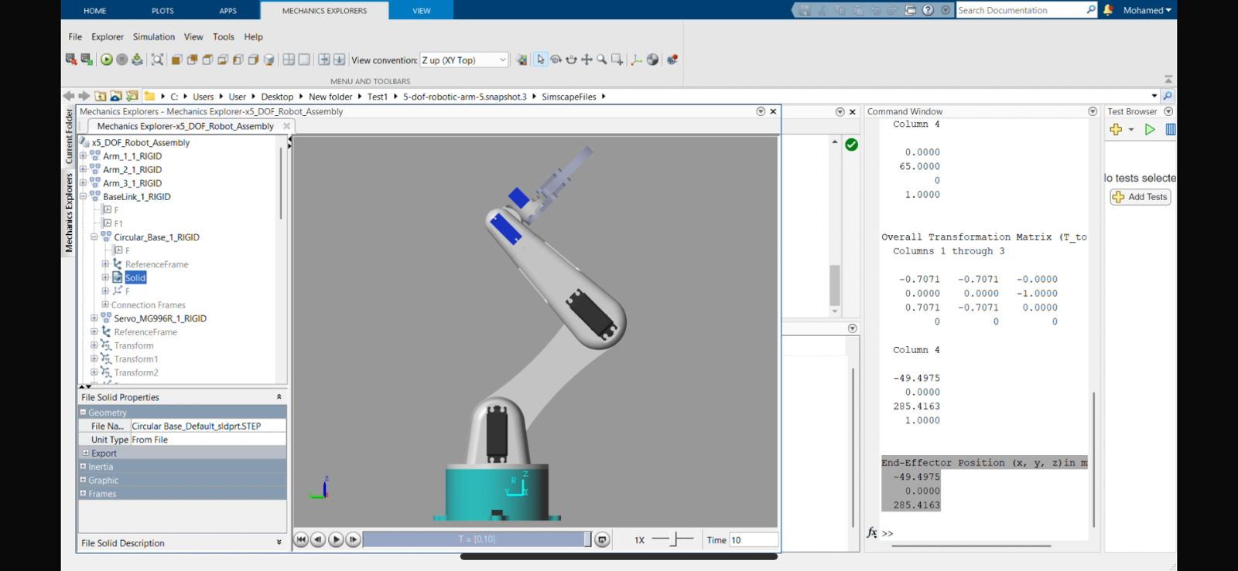

Comments:The results are almost identical between the Gazebo and Simscape.

1. **Hardware Fabrication Process**

The hardware fabrication phase involved 3D printing the robotic arm components based on the finalized CAD design from the previous milestone. The printed parts were partially assembled, with the initial sections of the arm successfully connected and fitted with servo motors. This stage focused on verifying the mechanical alignment of the joints and ensuring that the servo connections were properly integrated for smooth motion. Further assembly and fine adjustments will be carried out to complete the structure and prepare it for full system testing and control implementation.

1. **CONCLUSIONS AND FUTURE RECOMMENDATIONS**

This section should include the conclusions of your work, a summary of what you have done and the comments of the results.

Followed by the future recommendation in order to enhance your analysis or future steps to build a full functioning robotic system that you are going to implement in the upcoming milestone.